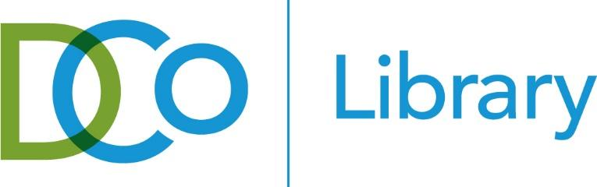

DURHAM COUNTY LIBRARY BOARD OF TRUSTEES
TUESDAY, JUNE 23, 2026
6:00 p.m.
Main Library

MEETING AGENDA
Time |  | Agenda Item | Responsibility
6:00 | 5 min | Call to Order  Public Comments | Carl Newman
6:05 | 5 min | Approval of Minutes | Carl Newman
6:10 |  | Location Reports
 | 10 min | Main Library | Claudia Aleman
 | 10 min | Business Services | Cierra Williams
6:30 |  | Board Business
 | 5 min | Old Business  - Check on strategic plan track | Ann McLain
 | 10 min | New Business  - Vote on Board member incumbents | Ann McLain
6:45 | 15 min | Library Report | Dana Conners
7:00 |  | Board Committee Reports
 | 5 min | Advocacy Committee | kynita stringer-stanback
 | 5 min | Development Committee | Carl Newman
 | 5 min | Outreach Committee | Tracy Jackson
7:15 |  | Library Family Reports
 | 5 min | Friends Report | Monika Tillman DeWitt
 | 5 min | Foundation Report | Carl Newman
7:25 | 5 min | Review of Action Items | Tracy Jackson
7:30 |  | Adjourn

